**Moving head Servo mod for Dr Who Pinball machine from Bally / Williams 1992**

**Ruud Rademaker, OWM Netherlands 29-10-2021**



Version 1.00 29-10-2021: initial version

Version 2.00 7-2-2022: Instructions for 3D printing: <https://www.thingiverse.com/thing:5231190>.

# OVERVIEW

In order to make the Dalek head move, a servo is fitted in the Dalek, which moves the head.

Over the years, my Dalek hardware went through a number of modifications.

* Prototype: The servo was fixed to the head, a rigid U shaped aluminium bracket in the Dalek body “held” the servo arm forcing servo+head to move.
* V0: The servo moved to the Dalek body and a bracket in the Dalek head held the servo arm. Rotating the servo, just caused the head to move. The servo was mounted in the body, by means of aluminium / wood brackets. These brackets provided a mechanism to adjust / center the head.

The Arduino software moved the servo. The principle was the same for all variants: it used the original signal (Solenoid25: connector J122-1) to start motion. Instead of a motor the signal was fed into an Arduino, that moved the servo much like a motor would. Normally the pinball firmware would detect the presence of this motor, by detecting movement. In this case an opto switch. The same Arduino provides this signal also (an output of the Arduino) that closes a switch in the pinball’s switch matrix: row 1 (connector J206-9)/ col 8 (J208-1).

This IO is determined by the pinball and did not change. What did change was the Arduino driver software. I went from a simple interface with buttons only, to a menu driven interface with a 16x2 LCD with a rotation encoder.

Next the body underwent modifications to hold more and more RGB LEDS. These leds were driven by a separate Arduino, as one Arduino did not have enough program space to hold all the code. This separate Arduino reads configuration files from a memory card and then lights up LEDS. The configuration files can conveniently by created from Excel. The Arduino LED option underwent different modifications, using TM1640 (driving 128 LEDS through a proprietary serial interface) and lateron HT16K33 (128 LEDS through I2C interface, can be daisy chained):

* V1: Two TM1640 for 13 rows of 5 RGB common kathode LEDS (so 3x65=195 LED) complex geometry (not a simple matrix) for the LEDS.
* V2: Two TM1640 for 13 rows of 5 RGB common anode LEDS (so 3x65=195 LED)
* V3: Three TM1640 for 24 rows of 5 RGB common anode leds and 1 row of 5 + left eye/right eye/nose RGB common cathode reds. (so 3x(24*5 + 5 + 3)=384 LEDS)
* V4: Three HT16K33 for 24 rows of 5 RGB common cathode leds and row of 5 + left/right/nose RGB common anode reds. (so 3x(24*5 + 5 + 3)=384 LEDS)
* V5: Four HT16K33 for 24 rows of 5 RGB common cathode leds and a row of 5 RGB common anode reds + separate HT16K33 in the moving head for a ring of 25 + 5 left eye/5 right eye/5 nose RGB common anode reds. (so 3x(24*5 + 5 + (5+5+5+24) = 375 + 120 = 395 LEDS)

In the last configuration with the 395 LEDS, only 2+2+5+8 = 17 LEDS are not used of the maximum of 4x128=512 LEDS.

The LED soldering in the Dalek body and LED configuration are detailed in another document: “[dr who.pdf](dr%20who.pdf)”. This document focusses on the Servo modification, first with the aluminum bracket later with the 3D pinted mount.

V6 introduces a new hardware mount, using a 3d printed holder for a MG90S mini servo.

This mount (V6) is described in this document, the software remained the same.

V7 Introduces a new software. Instead of two Arduino nano’s, one Wemos D1 mini is hosting both the LED as the servo software. The “flasher” signal for the pinball’s Dalek head is also an input for the LEDS in the head (Solenoid 14, J128-2, Brn-Blu) , allowing flashing of nose/eyes/ring and Dalek foot. Instead of an SD card, the onboard flash memory is used and instead of serial (bluetooth) interface Wifi is used. Instead of buttons/LCD an MQTT interface can be used.

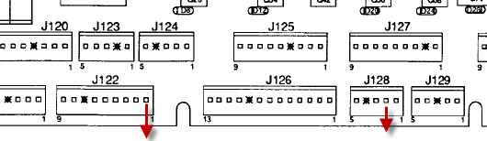

Figure 1 Switch Matrix Arduino outputs

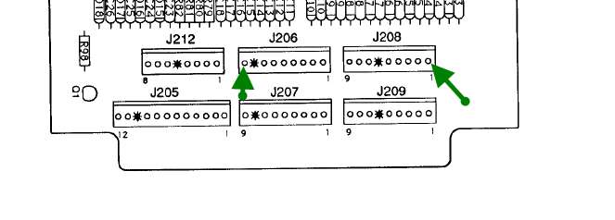

Figure 2 Solenoid Arduino inputs

# V0: Aluminium bracket, servo fixed in body with moving head.

Glue a aluminium bracket in the Dalek as indicated, hole for an M5 screw in the middle. Align it roughly parallel to the top. The plastic is not very precise.

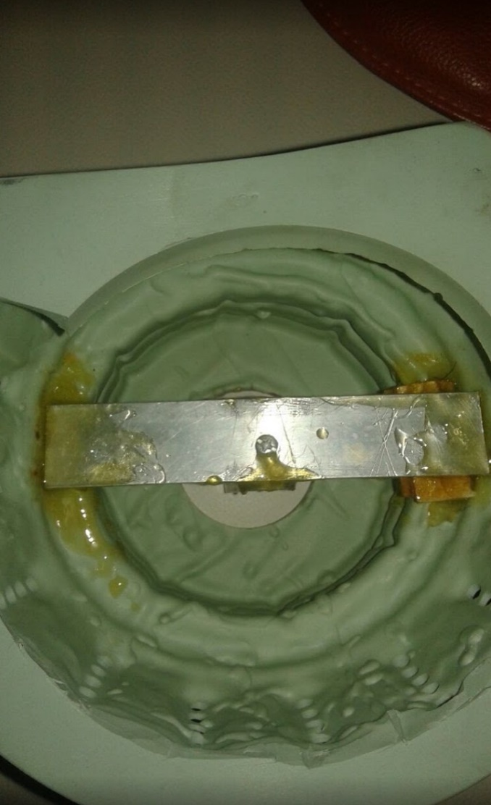

Prepare an aluminium plate, 4 holes in which you tab threads, big hole in the middle, that you can cover up with a ring. You can also make this of wood if you prefer, but then glue nuts to the wood, as tabbed threads will not hold the metal screws in wood.

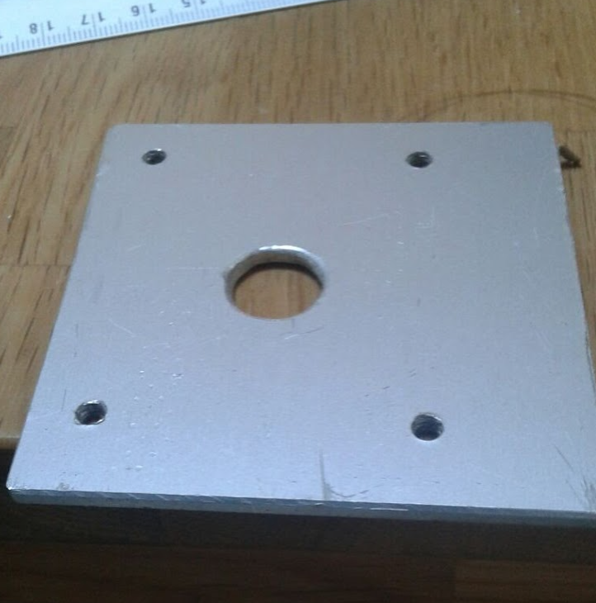ll

This plate will be held by one screw, with a big ring to allow you lateron to center / adjust the servo in the plane of this plate. It will fit like this:

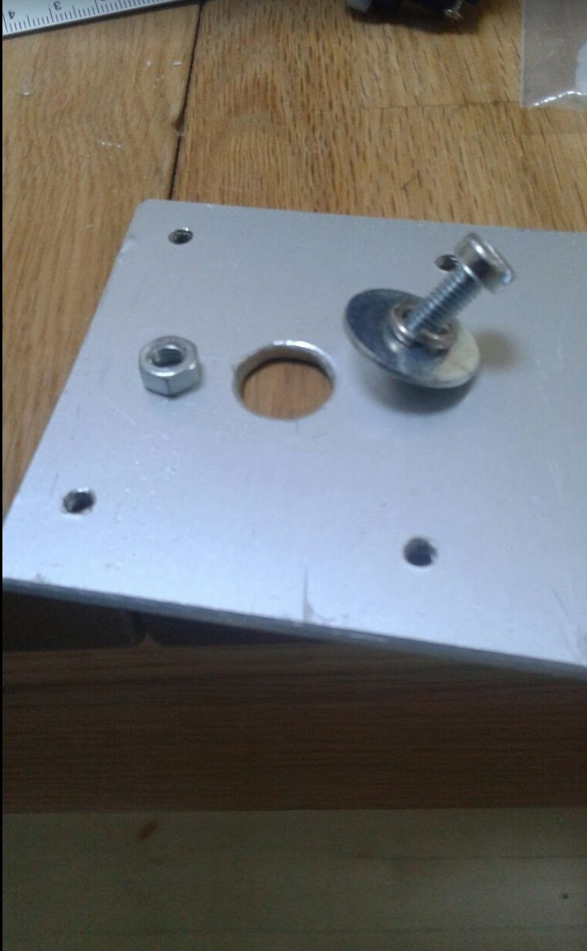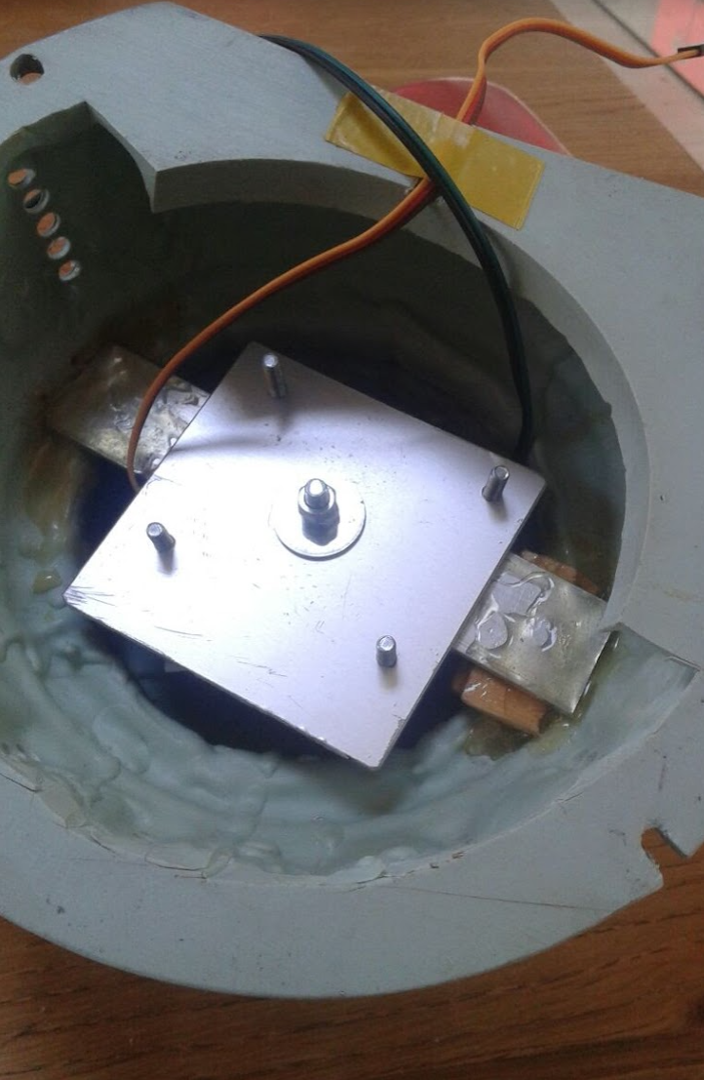

Left picture is seen from the bottom of the Dalek with the screws of the servo plate (coming up next) screwed in. If you make this aluminium plate from wood, then -as mentioned- glue 4 nuts where you see the bolts come through (or on the other side: more space there) to it, so that the screws form the servo plate fit and hold.

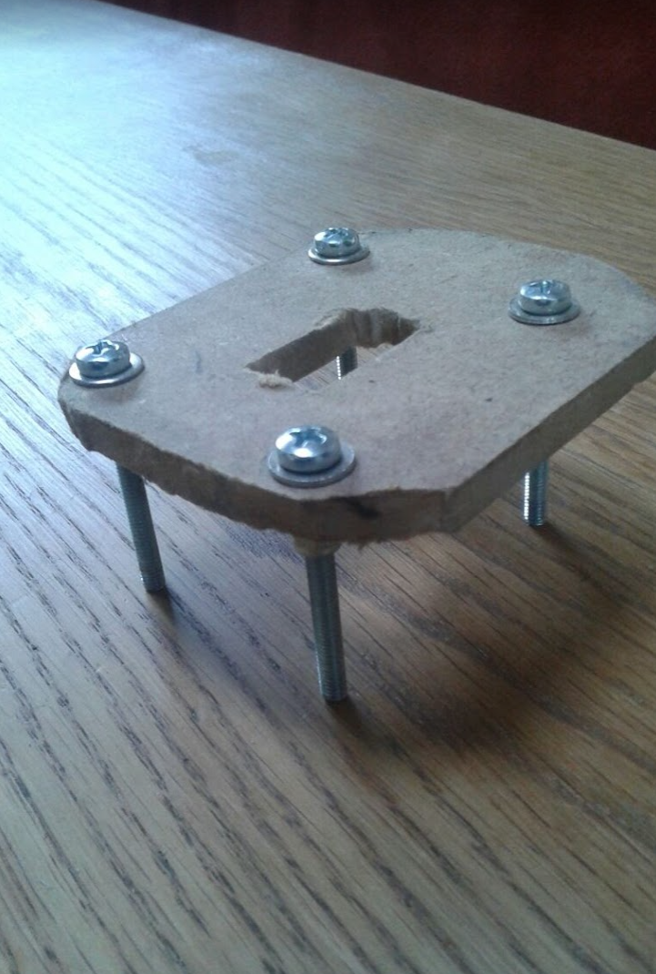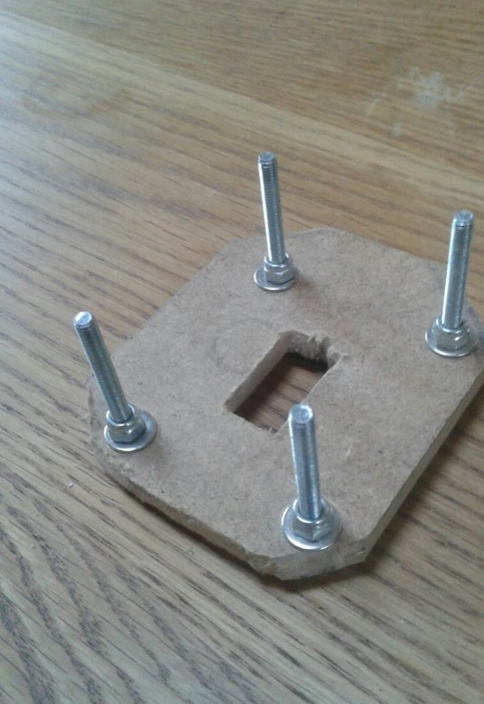

This (wooden) plate holds the servo in the middle and allows for 4 screws that can freely rotate in the holes in the wood and fit in the tapped holes of the aluminium plate. They are kept in place with lock nuts tightened loosely, allowing them to rotate freely in the wooden holes.

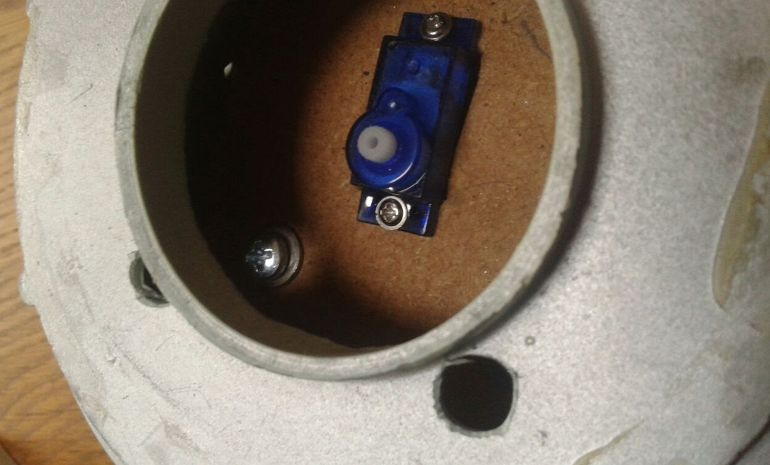

Now you can screw it in with the four screws to the mounted aluminium (or wood with glued nuts). The four screws allow alignment of the vertical axis to correct for skewness, to centre screw in the middle aligns the centre of rotation of the servo to the centre axis of the Dalek.

Finally, glue / screw some u-profile to the servo wheel. I also glued in some magnets.

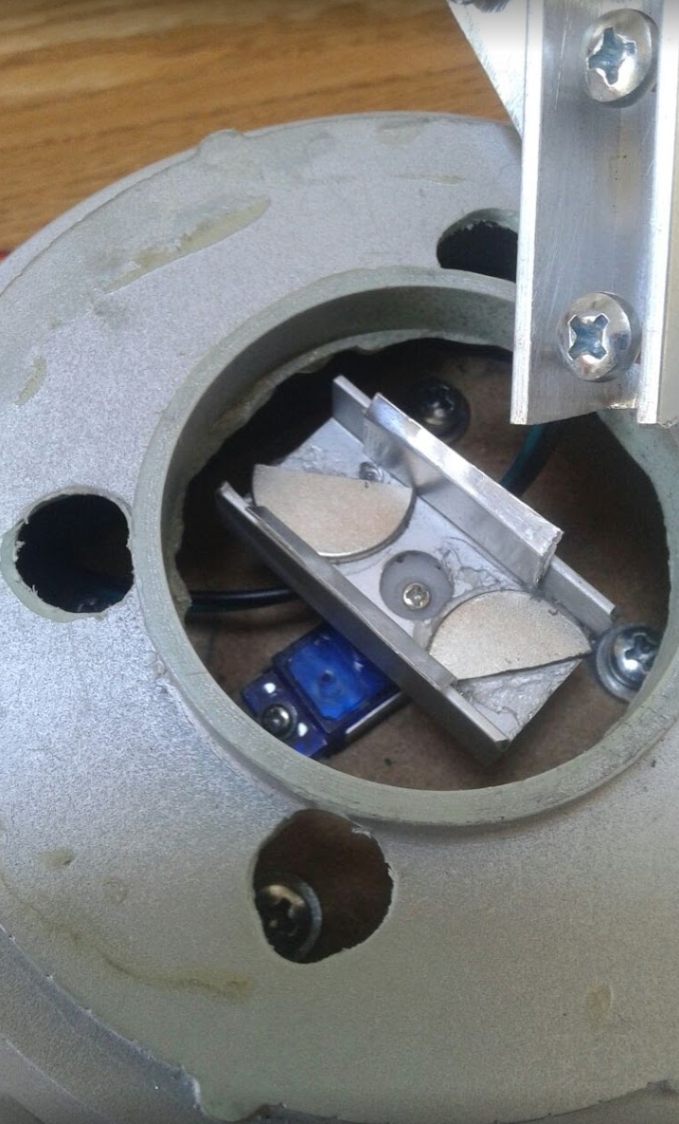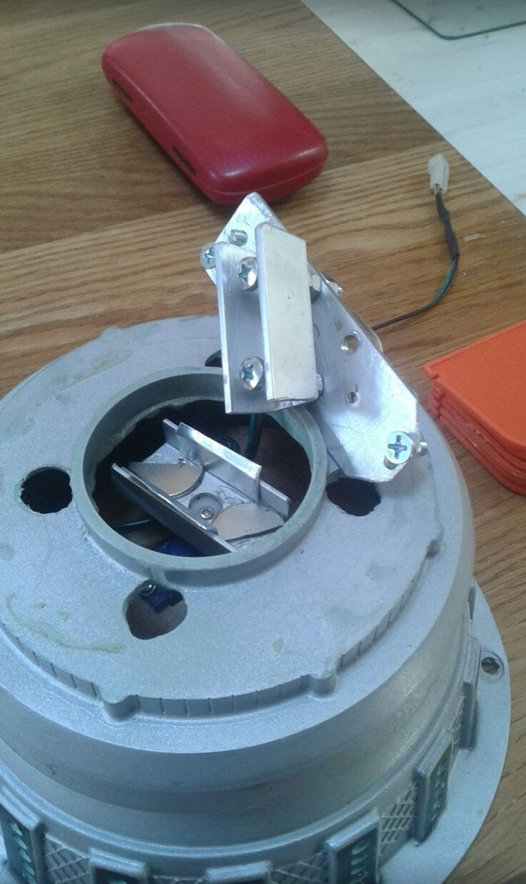

As you can see, I drilled holes to be able to adjust the 4 tilting/aligning screws from above.

In the servo u, a slightly smaller u–profile fits. This smaller u profile is attached to the repurposed bracket from the flasher. This smaller u-profile fits in the servo rotated u-profile and also has magnets / screws that engage magnetically with the larger u profile below.

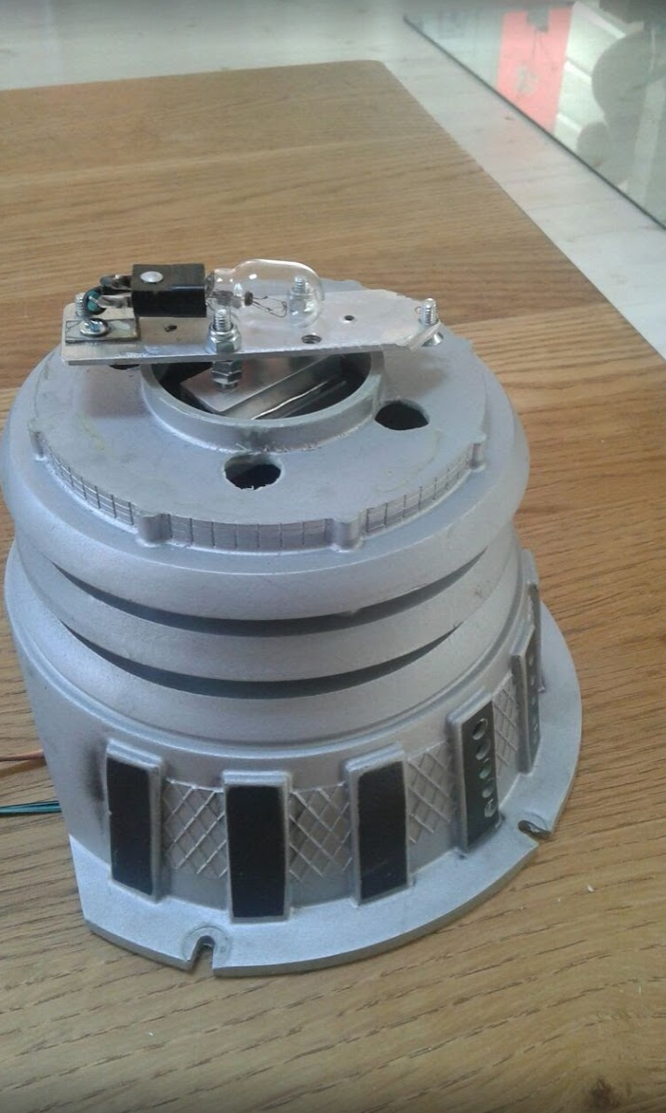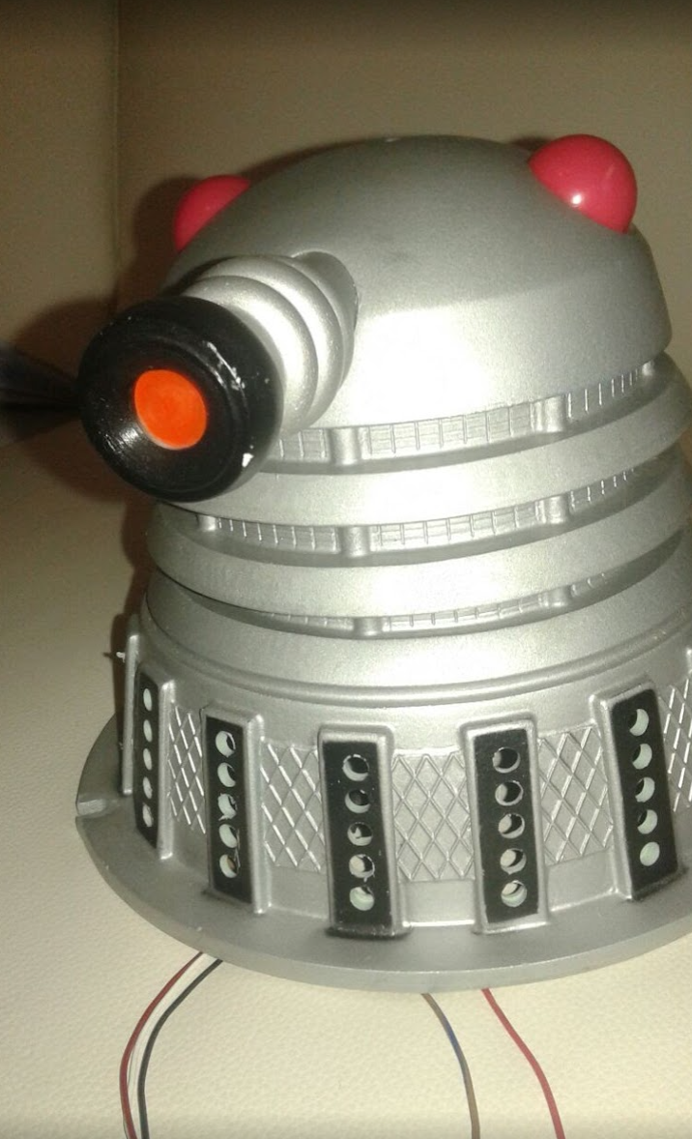

The top is only locked with magnets and two u-profiles make it fit. The head can always easily be lifted off therefore. The flasher still fits on top of this bracket, be it horizontally. Lateron I replaced the flasher wit 34 animated RGB LEDS and another HT16K33 (nr. 4) in the head.

The operation is totally invisible. Shown is a “lowres” 13x5 RGB Led version, but there is enough space for 25x5 RGB leds, so the bars in between the black bars are also filled with 5 LEDS each. With 25x5 LEDS you can display readable text.

# V6: 3D printed servo mount in the body moving the head.

This part documents the 3D printed mount. Software remained the same.  
Here you see the servohorn on top of the servo. Which will hold the Dalek head using one M3 12mm flat head bolt. In the 3D printed headmount-14.stl there is metal M3 threaded insert, which is melted in place with a soldering iron. It will also work without M3 threaded insert and a wood screw, but I liked the M3 threaded insert better.

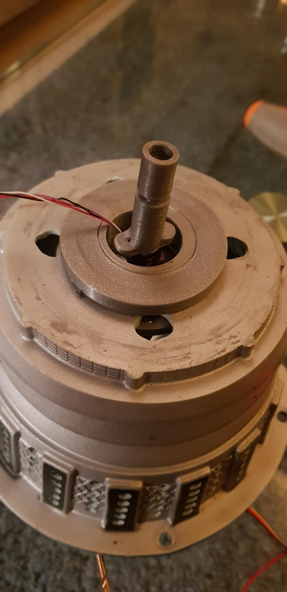

The head mount can be adjusted in length along the printed M8 thread and is fixed at the desired length by an also printed M8 nut. My adjusted servohorn/nut/headmount was 40mm tall. Different length headmounts as well as different M8 nuts (thinkness) are available I used the middle size haeadmount (headmount_16.stl) with a 4mm nut (Nut4.stl) combined with servohorn.stl

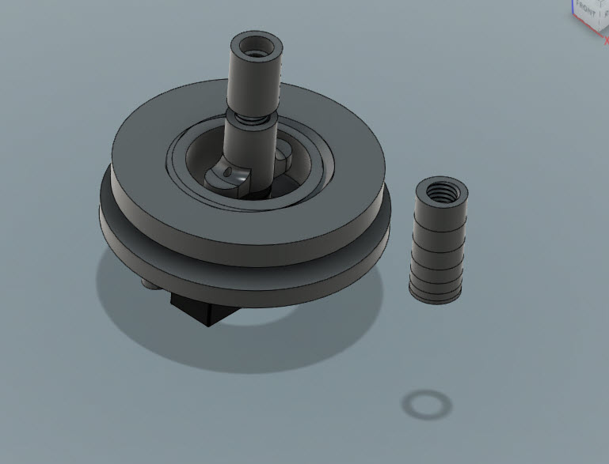.

Above you see all parts, with the nut4.stl on the mount invisible. The topperFitting.stl and the bottomFitting.stl can be screwed together over the plastic of the Dalek body. A newer version used a hex-form shape instead of circular, so that the screwed together plastic parts do not slip.

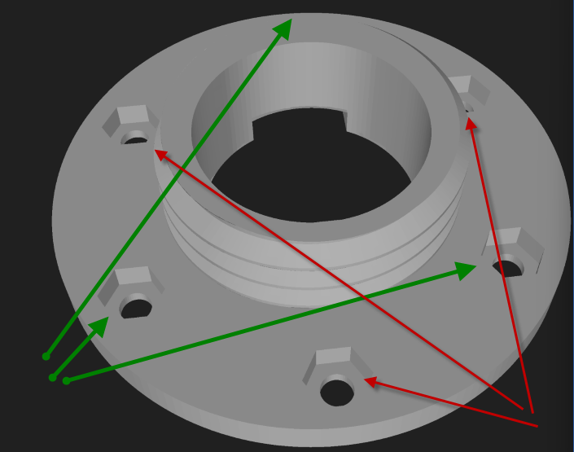

BottomFitting.stl has 6 hex spaces. Three capture DIN 934 M4 hex nuts, whereas the other three capture DIN 933 M4 hex bolts, so that the bolts protrude downwards into the Dalek body. This will hold the Servofixture.stl, which in turn holds the MG90S servo.

The three M4 nuts will optionally hold 3 (other) M4 bolts (hex/flat/Phillips/inbus doesn’t matter), that will hold the fitting in place by pressing the fitting from the plastic body. These 3 bolts are optional as the fitting holds quite strongly even without these 3 bolts. Servofixture.stl is held in place with another 3 M4 nuts (so you need 6 M4 nuts in total).

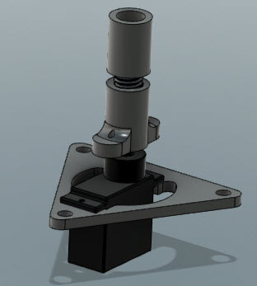

With both fitting parts invisible, you can imagine how the servohorm assembly is screwed with two tiny screws from below (these screws are not drawn) through the nylon servo horn after this servo horn is attached to the servo MG90S itself with the screw provided with the servo. You need to cut off parts of the biggest nylon servo horn in order to fit it to ServoHorn.stl.

The thingiverse published thing (<https://www.thingiverse.com/thing:5231190>) provides 3 different sized headmount_xx.stl’s and 7 nutx.stl’s providing a wide range of adjustability in height.

This assembly is fitted from below into the Dalek body and held in place by the three nuts to the 3 inserted M4 DIN 933 bolts. The fitting fits snugly over the plastic of the plastic pinball Dalek body, and the MG90S servo mount provides exactly centred rotational movement of the head.

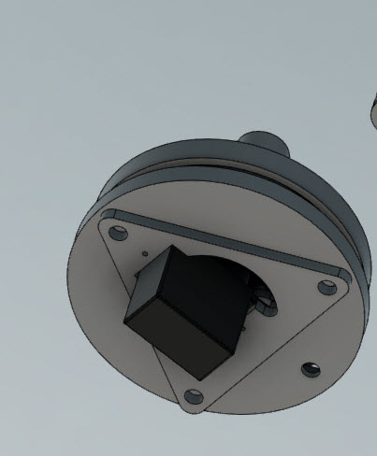

Now that the servo with its mount takes minimal space, there is enough space between the LEDS and the servo mount to place all necessary hardware in the head itself (3 stepdown convertors, one Wemos D1 mini, 3 optocouplers and bidirectional level shifters (3.3V to 5V)).  
  
The lower part can host the three KT16K33 drivers with all the LEDS, the head the fourth HT16K33 driver for nose / eyes and a 24 LED ring and there is room between servo / servo horn / dalek body / moving dalek head to feed the 4 required wires from the 3rd HT16K33 to the 4th HT16K33 for 24+3*X RGB LEDS in the head (I think I did 5 RGB in each eye and in the nose, so 39 RGB LEDS in total not sure however).

From the pinball you just need GND/+12V and 4 data wire Solenoid14/Solenoid25 as well as Row1/Col8 from the switch matrix.

Two optocouplers are for Solenoid14/Solenoid25 and one optocoupler is for Row1/Col8 of the switch matrix (so 4 wires in total).

Configuration is done over WiFi and an MQTT interface.

* ruud.rademaker@gmail.com